ACC Annual Scheme Access Reporting
Consultation Paper
February 2024

What is ACC annual scheme access reporting?
In 2023, an amendment to the Accident Compensation Act introduced a new requirement for ACC to report annually on levels of access to the Accident Compensation scheme by Māori and other identified population groups. The reports will include information on disparities in access, barriers to access and the causes.
Our proposed approach to access reporting will also allow us to investigate other factors that may impact on people lodging a claim, for example, where they live, if they are experiencing material hardship, and any other relevant factors.
The objectives of ACC’s annual scheme access reports are to:
  - improve the focus on, and understanding of, how people with personal injuries are accessing, or not accessing, the Scheme, and
  - increase transparency about levels of access to the Scheme, including any disparities in accessing the Scheme by different population groups.
What we learn as we write the reports will help us to identify gaps in access and develop an evidence-based approach to how we might best meet different people’s needs.
Before preparing the first report, we are required to consult on the methods we propose to use. The consultation timeline is:
February 2024
Consultation opens
April 2024
Consultation closes
April-June 2024
Report drafted
After 30th June 2024
Report provided to the Minister for ACC
Annual Scheme access report presented to Parliament.

How to have your say
We would like to hear your views. Your views and opinions will help us think about the approach we take to develop our new annual scheme access report.
We’d appreciate hearing from you by 8 April 2024. You can respond to one question or all of them, it’s up to you. Please also include your name and the name of your organisation if you are part of one.
You can tell us what you think by:
- visiting our ACC webpage
- using our feedback template
- emailing a Microsoft Word or Adobe Acrobat attachment to accessreporting@acc.co.nz
- Writing to us at:
Policy Manager
Accident Compensation Corporation
PO Box 242
Wellington 6140
New Zealand
If you have any questions, you can email us at accessreporting@acc.co.nz

How we will use the information you provide
The information you give to us will be used to help us develop ACC’s annual scheme access reporting process.
The information you give to us will only be reviewed and considered by the project team, including any personal or identifying details. We will store your information securely and destroy it after seven years. Your feedback won’t be publicly published. It might be summarised and used to help us give advice or updates to Ministers on how we’re meeting our scheme access reporting requirements under the Accident Compensation Act.
If we have any questions about what you tell us, we might contact you directly.
Personal Information
In the collection, use, disclosure, and storage of information, ACC will comply with the obligations of the Privacy Act 2020, the Health Information Privacy Code 2020 and the Official Information Act 1982. See ACC’s Privacy Notice for more information.

Contents
What is ACC annual scheme access reporting? 2
How to have your say 3
How we will use the information you provide 4
Personal Information 4
About the Accident Compensation Scheme 6
Introduction 8
Overall access reporting timeline 11
Our proposed approach for preparing the first annual scheme access report (2024) 12
Our proposed approach to preparing subsequent annual scheme access reports (second report onwards) 16
Evolving the survey approach 17
Developing a kaupapa Māori methodology 17
Proposed approach to developing the second report 18
Proposed approach to developing the third report 19
Engagement approach 20
Questions 23

About the Accident Compensation Scheme
In 1974, the Accident Compensation Scheme was set up to provide no-fault cover for people hurt by accident or injury, whether at work, at home or at play.

Our accident compensation scheme is unique in the world, and over the last 50 years we’ve built a system that is now part of our national DNA. New Zealanders know that if they get hurt, ACC exists to support them.

ACC has three functions:

Injury prevention | Rehabilitation | Compensation
We want to reduce the number and seriousness of injuries happening across Aotearoa. | We help cover the cost of treatment and rehabilitation so that people can regain their health and independence as much as possible. | We provide financial compensation to people for losses they incur because of their injuries.

ACC receives around two million claims a year ranging from minor through to serious and life changing. Most claims are for straight-forward injuries where we pay or contribute towards treatment. These kinds of injuries currently make up 93% of claims. The other 7% of claims are for injuries that are more severe and require a more complex approach for treatment and rehabilitation.
Even though the Accident Compensation Scheme is available to everyone, evidence shows us that not everyone has equal access, which means their injury needs are not being met.
Research shows that people who experience barriers to healthcare in general are less likely to lodge an ACC claim when they’re injured. They’re also more likely to have their claim declined, and less likely to access the full range of diagnostic and treatment support.
Research on access to the health system tells us that there are many factors that are likely to impact on access to the Scheme and people’s ability to lodge a claim. Age, gender, location and socioeconomic status are all known factors, among others.
There is a lot of evidence showing that some groups of people are less likely than others to lodge an ACC claim, even where they are more likely to suffer a serious injury, and they are more likely to have poorer long-term injury outcomes.
Our strategy for 2023-2033, Huakina Te Rā, incorporates our vision for a future where all people, whānau and communities can thrive. To achieve our goals under Huakina Te Rā, especially Mana Taurite | Equity, ACC is doing a range of work with communities and other agencies to increase access to the Scheme for Māori and other population groups, and to improve their health outcomes.
Annual scheme access reporting will help us to put the goals of Huakina Te Rā into practice.

Introduction
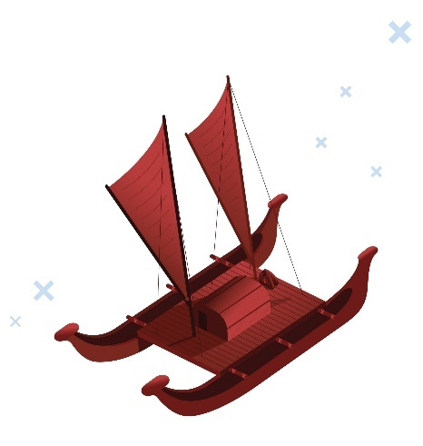
ACC strategy and accountability documents, for example Huakina Te Rā and Te Tauākī Whakamaunga Atu | Statement of Intent 2023 – 2027, refer to actions that we’re doing to improve our understanding of how Māori are accessing the Accident Compensation Scheme, but do not include detailed data and analysis about access to the Scheme for different population groups.
The Accident Compensation (Access Reporting and Other Matters) Amendment Act 2023 (the Amendment Act) specifies that Māori are to be included in each year’s report. This specification recognises the Crown’s obligations to Māori.
Other than Māori, the Amendment Act does not specify the population groups that should form the basis of the analysis and reporting. It requires ACC to identify those population groups, and the groups might change over time. By not specifying population groups the Act gives us the freedom to respond to new evidence or data showing different population groups experiencing disparities over time. This will help us deliver services in a way that supports improved access to the Scheme.
In addition to Māori, the population groups that we have identified as a priority for investigating disparities in access for the first scheme access report are:

Pasifika | Asian peoples | Disabled people
We selected these groups because there is a lot of evidence for the disparities they face in accessing the Scheme.
We have defined these groups according to StatsNZ Census definitions. In selecting these groups, we considered several factors relevant to ACC and our clients, including:
- health and social care access and outcomes
- known barriers to access
- availability of data
- whether reporting is achievable
- if the method we’re proposing is robust.
ACC has previously identified disparities in access to the Scheme for a number of population groups including Māori, Pasifika, disabled people, Asian peoples, women, young people, and older people. We know that these groups are less likely to make ACC claims, despite having had an injury.
Our most recent data analysis has also shown Māori, Pasifika and Asian claim rates are lower than for other population groups, and children with a disability were less likely to make an ACC claim than non-disabled children.
We have selected all disabled people as an identified population. This is because we identified a gap in our understanding of access to the Scheme for disabled people.
Disabled people are a diverse group with a wide range of physical, mental, intellectual or sensory differences. These differences become ‘disabling’ because of barriers society creates to participation and inclusion. In the 2018 census, one in four New Zealanders identified as disabled.
Prioritising populations inevitably involves selecting only a few groups on which to focus our efforts. For example, including large populations as the identified groups, such as children, older people or women would reduce the value of prioritisation.
The legislation, as well as our proposed methodology, also provides the flexibility to choose different populations for access reporting in the future, if evidence suggests barriers and disparities for groups that differ from our initial framing.
For example, over time we may expand on our current focus on Asian peoples to also cover Ethnic Communities more generally. We propose initially starting with Asian peoples as we can easily identify this group in our data and get a better understanding of barriers for them in the first instance.
There are other data variables to consider that may impact whether a claim is lodged; for example, age, gender, sexuality, location, material hardship factors, and other relevant factors.
Our approach to reporting allows us to consider these variables for Māori and identified population groups. We have retained the flexibility to report on variables of interest as they arise through our ongoing research and through our analysis in the StatsNZ research database.
Phased in over the next three years, the annual scheme access reports will provide analysis of Māori and other identified population groups. The analysis will include:
- the level of access to the Scheme in that financial year (from 2024)
- any disparities between any of those population groups or between those groups and any other group in accessing the Scheme (from 2024)
- any barriers affecting access to the Scheme by those population groups (from 2025)
- the cause of, or factors contributing to, those disparities and barriers as identified by ACC (from 2026).
ACC’s first report (2024) will also:
- confirm that we will report on Māori in all annual scheme access reports
- identify the population groups that we propose to report on, in addition to Māori, in the annual scheme access reports
- describe how we propose to engage with Māori and the identified population groups when preparing the second and third annual scheme access reports
- describe the methods that we propose to use in preparing the second and third annual scheme access reports.
Overall access reporting timeline
Our new scheme access report will be an annual process that will evolve over time. It’s likely that we will work closely with the communities we propose to report on when we’re developing the reports. You can find more detail on this in the ‘Engagement approach’ section.
The diagram below outlines the overall scheme access reporting timeline.
Engagement with reference groups on report findings and
next steps
Finalise methodology for second report
PHASE TWO
Pilot data analysis conducted and proposed methodology for first report developed
Paper to consult on methodology for first report drafted
(this document)
Consultation with public and population agencies
PHASE ONE
Methodology for first report updated based on consultation feedback
Consultation feedback on methodology for first report analysed
Data analysis for first report conducted
Publish second report (2025)
Work with reference groups and identified stakeholders to interpret findings
Data analysis and research for second report conducted
Finalise methodology for third report
PHASE THREE
Data analysis and research for third report conducted
Engagement with reference groups and stakeholders on report findings and next steps
Publish third report (2026)
Ongoing engagement with reference groups and stakeholders on report findings and next steps
Work with reference groups and identified stakeholders to interpret findings
First report published (2024)

Our proposed approach for preparing the first annual scheme access report (2024)
Please tell us what you think about this by responding to Question 1 in the ‘Questions’ section.
People access the Accident Compensation Scheme in different ways, including:
- through injury prevention initiatives | - by lodging a claim | - by accessing cover,  and then accessing entitlements
For the purposes of access reporting, we have focused initially on claim lodgement as a measure of entry to the Scheme. Existing research and data analysis shows that claim lodgement is an access point where disparities exist.
ACC has historically used a claim lodgement ratio to measure access to the Scheme. But the claim lodgement ratio assumes that people within population groups have the same rates of injuries as others. The claim lodgement ratio does not tell us how many people are getting injured within a particular group and not lodging a claim. The claim lodgement ratio also does not tell us about variable access to entitlements.
To meet the requirements of the Amendment Act, we need to access alternative data sources, including surveys and linked cross-government data available in the Stats NZ research database.
The methods we propose to use to help us understand levels of access, disparities in access, and barriers to access are outlined below.
Method 1: Survey-based research to estimate how many injured people do not lodge claims with ACC
Our exploratory data analysis has shown there are no current datasets that provide information about injury prevalence in New Zealand. Therefore, we propose to use a survey approach.
The survey approach will evolve over time, initially using an existing ACC-run survey and moving to using a representative survey that enables more detailed analysis longer-term.
A survey approach will allow us to identify how many injured people lodge claims with ACC, broken down by Māori and the population groups we have identified. This meets our legislative requirement to report on levels of access and disparities between groups.
For the first year’s report, we will use an ACC survey to establish baseline estimations of access disparities for Māori and identified population groups.
We will survey 580 New Zealanders every month. The results of this survey are representative of the NZ population who are aged 18 years and older. This means that results from the survey are weighted to be representative of population proportions in terms of gender, age, income, region and ethnicity.
In the ACC survey, Māori and Pasifika populations are over-sampled to allow more robust analysis when looking at results for these populations in isolation. This is because the proportion of these ethnicities are lower within the New Zealand total population, and Māori and Pasifika are less likely to participate in surveys.
The ACC survey also includes a question for people to identify as disabled. The disability identifier question was designed with input from ACC disability advisors and researchers.
The injury question that has been included in the ACC survey is based on the results of exploratory research conducted in the StatsNZ Research database on injury questions used in previous surveys when injury was asked about.
The ACC injury survey question is ‘In the last 12 months, have you had one or more injuries?’ followed by ‘Did this injury or any of these injuries stop you from doing (any other of) your usual activities for more than a week?’
The adult injury rate for Māori and identified population groups will be estimated from answers to this question.
Answers to the question will be matched with ACC claims data for survey participants who have given permission to do so. When survey participants say that they have had an injury and there is no associated claim for that injury, this means there is an access disparity.
From this, we are able to estimate baselines for access disparities for lodging a claim for adult Māori, Pasifika, Asian peoples and disabled people.

Method 2: Analysis in the StatsNZ research database for a more nuanced understanding of the barriers to lodging a claim, and to understand trends in access over time
While a survey approach provides a view of injured people’s access to the Accident Compensation Scheme, there will be some limitations associated with the detail we can provide through this reporting.
So, we also propose to use the StatsNZ research database to access a greater breadth of data variables. This means we can report on factors that impact the likelihood of having an ACC claim for Māori and identified population groups, for example: age, gender, location, socio-economic status, industry, education, health, housing status, and whether people were born overseas or in New Zealand.
This enables us to explore the compounding challenges people may experience in accessing the Scheme.
Research in the StatsNZ database will provide a more detailed understanding of the multiple factors that impact on whether people lodge a claim. Once we understand this, we will be able to meet our legislative requirements to describe barriers to access for Māori and identified population groups.
Having a more detailed view of population groups’ access to the Scheme will also help us target the barriers they face.
Finally, we will use the StatsNZ research database analysis to develop an analysis of the data over time that allows us to understand access trends over the longer term.
The diagram on the following page outlines how we will meet our legislative reporting requirements.
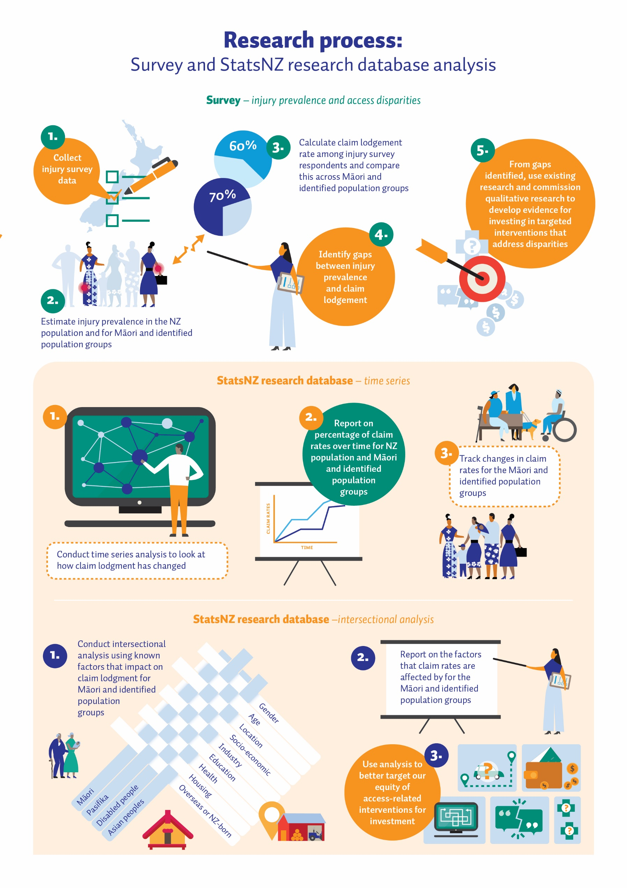
Our proposed approach to preparing subsequent annual scheme access reports (second report onwards)
We are thinking ahead to how we will approach the development of our proposed methodology for report two (2025) and three (2026).
We will present a proposed methodology for these reports as part of the first report (2024) and engage with interested people and groups as we develop these methodologies. Our approach to engagement is outlined in the ‘Engagement Approach’ section (pg. 20).
Based on exploratory data analysis, we have developed an initial approach for reporting on levels of access, disparities in access, and identifying barriers to access and what causes them.
We expect this approach to evolve as we learn from the findings from the first report, discuss the implications with interested people and groups, and improve our own data collection to ensure we can report more accurately, for example on disability and iwi affiliation.
We will also work to expand our understanding of disparities in access to the Scheme. This includes exploring how to track access points other than claim lodgement as a measure of entry to the AC Scheme, such as access to Injury Prevention initiatives, access to entitlements, and other factors.
The proposed approach for the second and third report is to:
  - use survey data to match with ACC claims to report levels of access and disparities in access (survey data collection will be expanded to include children)
  - conduct analysis of data points over time at evenly spaced intervals in the StatsNZ research database to track changes in levels of access and disparities in access
  - analyse factors impacting on claim lodgement in the StatsNZ research database to investigate barriers
  - conduct qualitative research required to fill gaps in knowledge for identified population groups about access, barriers, and causes
  - continue the engagement approach with interested people and groups to collaborate on approaches, interpret data, and validate findings.
At this stage, we anticipate that, in addition to Māori, the identified population groups - Pasifika, Asian peoples and disabled people - will be the focus of the second and third reports, but these may change over time. The findings of the analysis for these reports may show different groups facing disparities, and therefore those which would need to be reported on. This approach enables ACC to respond to new evidence about which population groups are facing disparities.

Evolving the survey approach
After using the ACC survey to estimate our baselines, we intend to work with StatsNZ to add an injury survey question to an existing nationally representative survey. Using an existing StatsNZ survey will ensure representative population sampling, including children, and avoid increasing the burden a new survey would place on the New Zealand population.
To design an appropriate injury survey question for inclusion in a StatsNZ survey, we will work with internal and external experts and stakeholders. We will work with relevant government agencies to design the injury survey question, including StatsNZ, Ministry of Health, Te Puni Kōkiri, Ministry for Pacific Peoples, Ministry for Ethnic Communities, and Ministry of Disabled People.

Developing a kaupapa Māori methodology
We are reporting on Māori as a separate population group. Our first year’s report will provide initial comparisons for levels of access between Māori and non-Māori.
Working with external Māori research experts, stakeholders, representatives, and partners, a kaupapa Māori methodology - research which is by Māori, for Māori and with Māori - will be developed to analyse access disparities, barriers and causes for Māori from a Te Ao Māori perspective.

Proposed approach to developing the second report
Please tell us what you think about this by responding to Question 2 in the ‘Questions’ section.
In 2025, ACC will explore the barriers to access for groups where there are found to be disparities. This will include the data that is measured over time at evenly spaced intervals to begin to track any changes in access levels.
We will also continue to build on our ability to analyse and report on scheme access for different groups. This will include further analysis on factors that impact on claim lodgement and further identification of population groups.
We have conducted research into the barriers to access to the health and social system for Māori and identified population groups. We have a basic understanding of these barriers to access. The survey data and the StatsNZ research database analysis will allow us to build on this knowledge. This method will help us to gain a more targeted understanding of barriers to access for subpopulations within the Māori population and identified populations.
We will work closely with interested people and groups including relevant research experts, government agencies responsible for working in partnership with population groups, and community representatives. We will work with them to discuss and validate research findings and identify any gaps to better understand our identified populations and the barriers they face, and to direct further investigations.
We will conduct qualitative research, such as interviews and focus groups, to fill gaps in our understanding of the barriers to access.

Proposed approach to developing the third report
Please tell us what you think about this by responding to Question 3 in the ‘Questions’ section.
The third report will build on the work of the first and second reports, to provide:
  - reporting on levels of access from survey data and ACC claims
  - any identified changes in access levels and disparities for Māori and identified population groups from analysis of the data over time
  - identified barriers to access
  - identified causes of, or factors contributing to, those disparities and barriers to access.
To identify the causes of barriers to access and develop our understanding of what we can do to improve delivery of services to support access to the scheme for injured people, we plan to conduct qualitative research, such as interviews and focus groups, with Māori and other identified population groups.
The qualitative research with Māori would be designed and led through the parallel kaupapa Māori methodology.
We will combine the findings and analysis of our qualitative approach with existing research on the causes of, or factors contributing to those disparities and barriers.
It is likely that some of the causes, or contributing factors will be linked to the wider health and disability system and other structural factors.
We will work with researchers and the agencies responsible for working in partnership with Māori and the identified populations to understand their existing research on barriers to access. This approach also reduces research burden on Māori and identified population groups.
ACC will continue to conduct analysis and consult and engage with Māori and other interested people and groups to validate our understanding of the causes of disparities in access and describe these in the third annual scheme access report.
From this, we can understand how ACC can partner with agencies and communities to start to address the barriers and their underlying causes.
Engagement approach
Please tell us what you think about this by responding to Question 4 in the ‘Questions’ section.
To support the development of the annual scheme access reports, ACC will work closely with interested people and groups including research experts, government population agencies, and community representatives. We will work together to discuss, interpret and validate research findings, and identify any gaps to better understand our identified populations and the barriers they face. This work will inform and direct further investigations into disparities in access and barriers to access.
As part of implementing Huakina Te Rā and achieving our dual-framed strategic goal Mana Taurite | Equity, aCC is developing a Mana Taurite | Equity Action Plan. The focus areas of this plan will include commissioning appropriate interventions to respond to barriers and inequities identified through our research and insights work programme. This includes insights from this consultation, access reports, data, existing research, literature, customer feedback and other qualitative channels, as well as insights gathered from project work already underway at ACC.
Engagement for subsequent reports will evolve in line with the phased approach to our consultation and reporting. In the first report, we will use our existing engagement forums, platforms and relationships to reach our identified populations such as presenting and discussing our proposed methodology with some of our Customer Advisory Panels and other interested people and groups with a focus on our identified populations.
We will also develop a forward-looking engagement plan for each identified population group based on ACC’s established engagement frameworks. This will support us to validate existing research and better understand the barriers to access and causes of disparities in access. This plan will be outlined in the first report and to develop it, ACC will work with community organisations and internal and external researchers and experts. We intend this to include people and whānau who have not engaged with ACC when injured, as well as those who have experienced barriers when accessing ACC.
We will work with StatsNZ and relevant ministries to design an injury survey question for the nationally representative survey. In this, we will ensure that the survey language, structure, sampling approach, data collection, analysis and interpretation of findings facilitates ongoing engagement with Māori and identified population groups.
For the first year’s report, we will work with internal and external stakeholders to assist with interpretating the data and insights from access reporting work. External stakeholders will include the ACC Strategic Advisory Panels, StatsNZ, relevant ministries, and groups or individuals recommended to us by organisations and panels.
ACC will work with Māori research experts, interested people and groups, and representatives, to develop a kaupapa Māori methodology to understand access disparities, barriers and causes for Māori from a Te Ao Māori perspective.
The report methodology for 2024 provides a foundation from which we can estimate baseline disparities in access for Māori. In reporting, we will present Māori statistics separately.
We will work with internal ACC Māori research experts and seek advice from external Māori stakeholders, such as Te Puni Kōkiri, kaupapa Māori research and data experts, research units within iwi entities where possible, and any other recommended organisations and groups to develop a kaupapa Māori workstream for access reporting.
We anticipate that feedback from Māori during this consultation process will also provide indications of direction on who to design with and how the kaupapa Māori workstream will be developed.
The diagram on the following page outlines how we picture the flow of information.

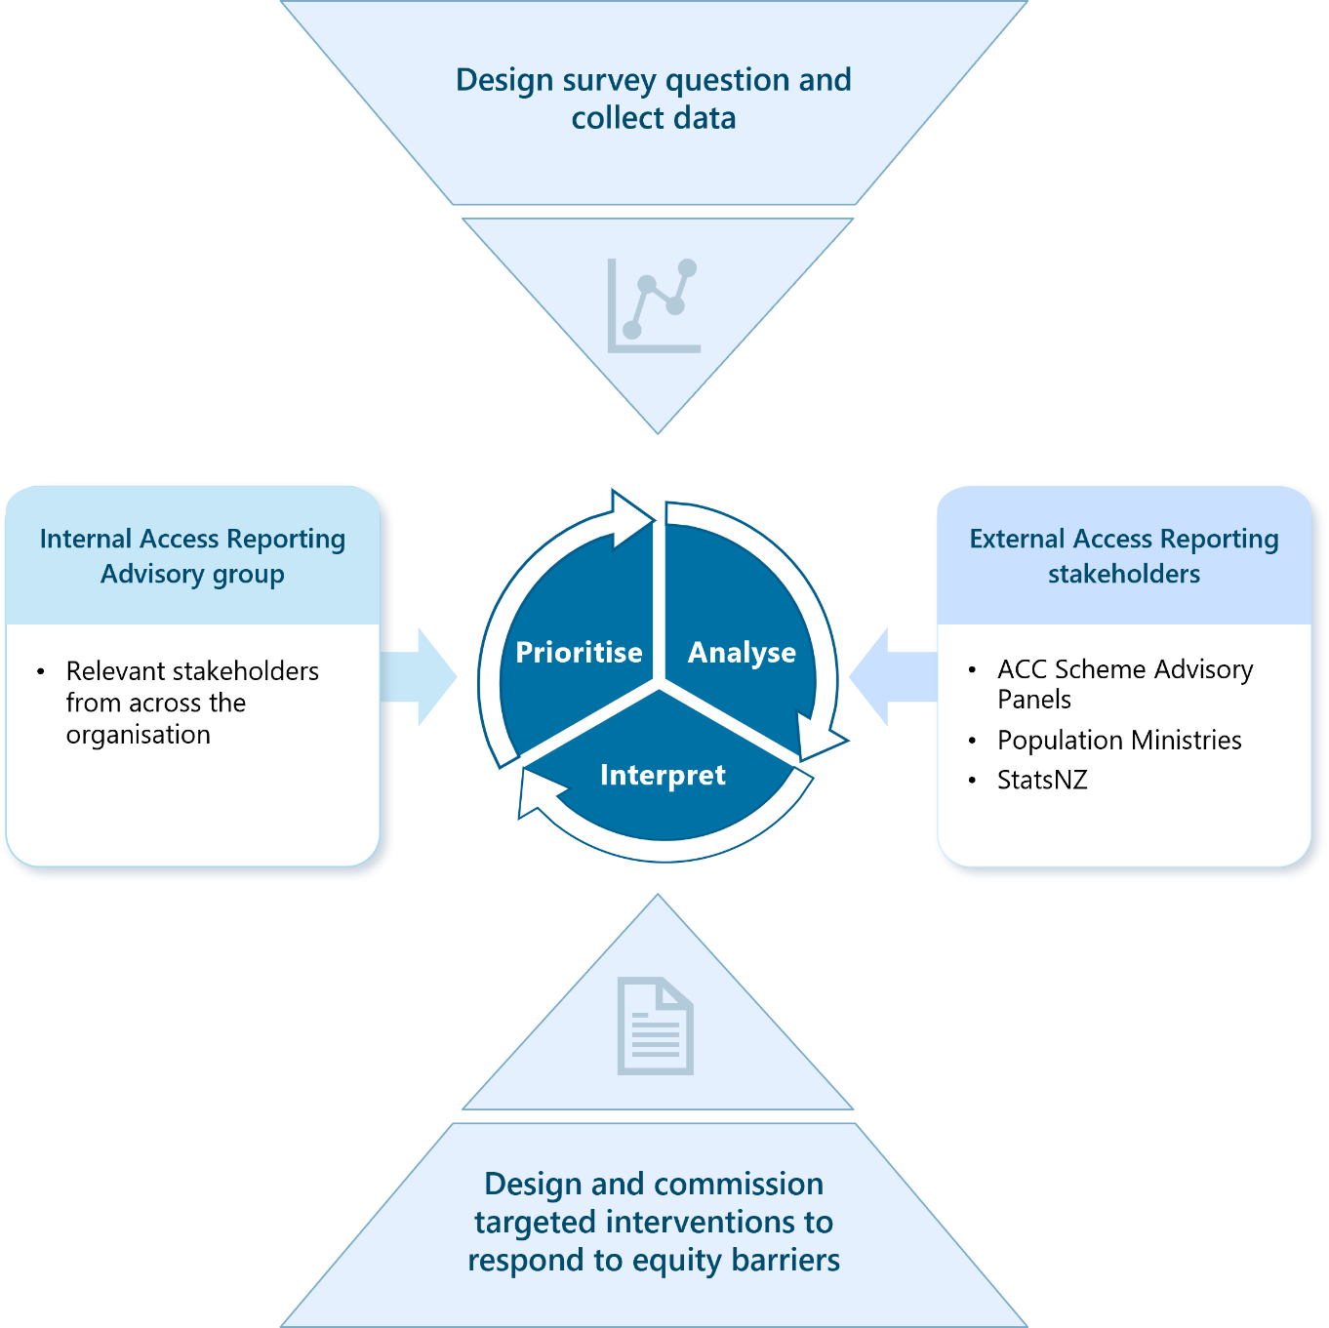
Questions
There are four areas that we would like to hear your views on. You can respond to one question or all of them, it is up to you.
You are welcome to provide any data or evidence to support your views. We suggest using bullet points to make the main themes of your response clear.
Question 1: Proposed methodology for the first report (2024)
ACC proposes using survey data to estimate the number of injuries for the Aotearoa New Zealand population, Māori and identified populations groups. Survey data will be matched to ACC claims data to indicate levels of access to the Accident Compensation Scheme. ACC will use this method to determine claim lodgement disparities for Māori and identified population groups.
Do you consider that this proposed method will enable ACC to usefully report on levels of access to the Scheme for Māori and identified population groups?
- Yes
- No
- Don’t know
Please provide comment on your answer in the box below, along with any data or evidence, and any other factors that you consider important, or suggestions for strengthening the proposed method.

Question 2: Proposed approach to developing the second report (2025)
For 2025, while reporting on levels of access and disparities in access, ACC will conduct data analysis in the StatsNZ research database to describe the barriers to access for Māori and identified population groups. ACC will also continue to engage with interested people and groups to validate findings and help interpret data.
We will further refine this approach through engagement with interested people and groups and present the proposed methodology in our first report (2024).
As we develop the proposed methodology for our second report, is there anything else we should consider?
- Yes
- No
- Don’t know
Please provide comment on your answer in the box below, along with any data or evidence, and any other factors that you consider important, or suggestions for strengthening the proposed method.

Question 3: Proposed approach to developing the third report (2026)
For the third report (2026), ACC will report on access levels, disparities (first report) and barriers (second report), and also include a description of the causes or factors contributing to those barriers or disparities for Māori and identified population groups. ACC will also continue to engage with interested people and groups to collaborate, interpret data, and validate findings.
We will further refine this approach through engagement with interested people and groups and present the proposed methodology in our first report (2024).
As we develop the proposed methodology for our third report, is there anything else we should consider?
- Yes
- No
- Don’t know
Please provide comment on your answer in the box below, along with any data or evidence, and any other factors that you consider important, or suggestions for strengthening the proposed method.

Question 4: Proposed engagement approach
ACC will engage with interested people and groups including research experts, government population agencies, and community representatives. This will involve collaboration, assistance with interpreting findings, identifying gaps, and validating research findings to better understand our identified populations and the barriers they face and to direct further investigations.
We will present a full proposed engagement approach in our first report (2024). While we are developing the engagement approach, is there anything else we should consider? For example:
- Who do you think ACC should engage with? Please provide contact details or any other information you think will be helpful.
Please provide your answer in the box below:

- Who do you think ACC should engage with on kaupapa Māori methods and kaupapa Māori workstream to be developed to support access reporting? Please provide contact details or any other information you think will be helpful.
Please provide your answer in the box below:

You can tell us what you think by:
- visiting our ACC webpage
- using our feedback survey
- emailing a Microsoft Word or Adobe Acrobat attachment to accessreporting@acc.co.nz
- Writing to us at:
Policy Manager
Accident Compensation Corporation
PO Box 242
Wellington 6140
New Zealand
If you have any questions, you can email us at accessreporting@acc.co.nz
Thank you for taking the time to provide your feedback to us.

The Accident Compensation (Access Reporting and Other Matters) Amendment Act 2023 (Amendment Act).
Accident Compensation Act 2001 section 278B.
See ACC’s 2023 Annual Report here: https://www.acc.co.nz/assets/acc8519-acc-annual-report-2023.pdf.
For more information on StatsNZ population ethnicity definitions see https://www.stats.govt.nz/topics/ethnicity. For the StatsNZ definition of disability, see https://www.stats.govt.nz/topics/disability.
See: McMeeking S, Tarena E, Williams M et al. 2022. Whiria te Muka Tangata: Anti-Racism Systems Change. A Preliminary Model for the Aotearoa New Zealand Health System. Wellington: Ministry of Health. Accessed online: Whiria te Muka Tangata: Anti-Racism Systems Change | Ministry of Health NZ. Ministry for Pacific Peoples. (2022). Pacific Wellbeing Strategy: Weaving all of government. Progressing Lalanga Fou. Wellington: Ministry for Pacific Peoples. Accessed online: All-of-Government-Pacific-Wellbeing-Strategy.pdf (mpp.govt.nz). Ministry for Ethnic Communities. (2022). Former Refugees, Recent Migrants and Ethnic Communities Employment Action Plan. Wellington: Ministry for Ethnic Communities. Accessed online: https://www.ethniccommunities.govt.nz/resources/research-and-reports/former-refugees-recent-migrants-and-ethnic-communities-employment-action-plan/. Office for Disability Issues. (2016). New Zealand Disability Strategy 2016-2026. Wellington: Ministry for Social Development. Accessed online: pdf-nz-disability-strategy-2016.pdf (odi.govt.nz). Ministry of Health. (2023). Health and Independence Report 2022. Wellington: Ministry of Health. Accessed online: Health and Independence Report 2022.
The claim lodgement ratio is the ratio between the claim lodgement rate per head of population for an identified group benchmarked against the claim lodgement rate for all New Zealand. This measures the rates at which people with different demographic characteristics are lodging injury claims.
This is StatsNZ’s Integrated Data Infrastructure that holds de-identified microdata about people and households. For more information, see https://www.stats.govt.nz/integrated-data/integrated-data-infrastructure/.
Currently, these include the Scheme Customer Advisory Panel, Pasifika Advisory Panel, Whānau Oranga Pūmau and the Sexual Violence Panel.

